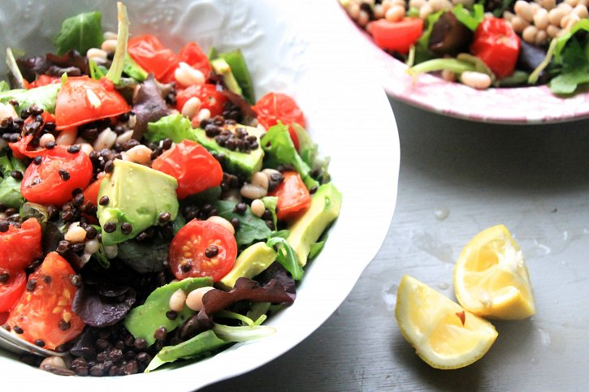

BELUGA LENTIL & WHITE BEAN SALAD

**04 January 2015**

**Beluga Lentil & White Bean Salad with Baby Leaves, Roasted Tomatoes and Avocado**

**Happy New Year everyone! I hope you’ve all had a really love holiday and are feeling refreshed and gearing to go for another year. I’m sorry I haven’t posted so many recipes on Naturally Sassy in the last few weeks, but after such a busy 2014 I took a few weeks out to be with my family and just breath. Anyways, I’m back and with so much inspiration for loads more recipes and features on the website - I can already tell 2015 is going to be such a great year.**

**At this time of year we’re all creating new intentions, resolutions and wishes for the new year - most of which are health related. But going from a christmas lunch to a juice detox in just over a week isn’t too realistic. For me, the new year brings with it delicious winter salads, warming soups and plentiful bowls of porridge! Today I’m sharing a recipe with you for a Beluga Lentil & White Bean Salad with Baby Leaf Lettuce, Roasted Tomatoes and Avocado - a flavour packed lunch, that is brimming with plant based protein to stave off hunger. It’s also brilliant if one of your resolutions is to become fitter, as the protein will support your muscles post workout recovery. As a ballet dancer I’m always looking to make sure I include some form of protein in each meal, and often try combining proteins to attain a wider range of essential amino acids. This is a great example of this, and will do your body the world of good.**

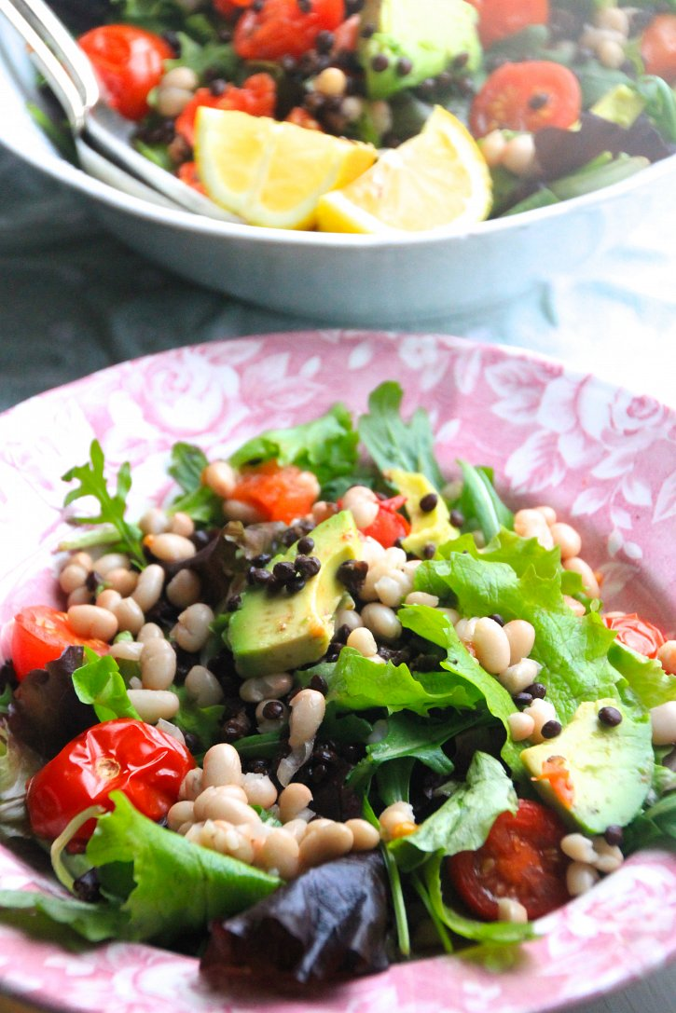

INGREDIENTS:

**Serves 4**

**500g cooked Beluga Lentils**

**400g white butter beans**

**2 avocados, pealed, de-stoned and sliced**

**a dozen cherry tomatoes, halved**

**5 large handfuls of baby leaf salad**

**Dressing:**

**Juice 2 lemons**

**2 tsp pure 100% maple syrup**

**2 tablespoons olive oil**

**1 tsp tamari**

**pinch of salt**

METHOD:

**Start by preheating the oven to 190 degrees celcius. Put the sliced tomatoes on a roasting tray, drizzle with olive oil and a pinch of salt - put in the oven to roast for up to 30 minutes. You can take them out before but they may be a little watery!**

**Meanwhile add all other ingredients into a bowl, and toss.**

**Mix the dressing ingredients together well, before pouring ontop of the salad ad tossing again. Serve & Enjoy!**

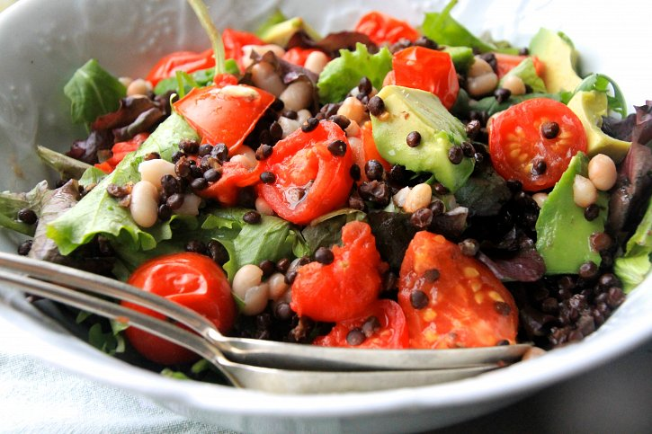

**- See more at: http://www.naturallysassy.co.uk/recipes/beluga-lentil-white-bean-salad#sthash.FOpcTIAI.dpuf**